BUGS AFTER RETEST OF MARKET PLACE
RESELLER ROLE:
- Register Deal >> select Deal registration option>>customer info>>deal details>>for verification click send code for verification CTA>> no emails sent to the customer.
- Go to dashboard>> Register new Deal>> select deal type as deal registration with full protection and verification>>customer info>>enter deal details>>verify email>>complete declaration & e-sign>>click lock and register deal>> Registered deal is not visible on frontend to distributor and reseller in my deals menu which was named as TEST BIZ.
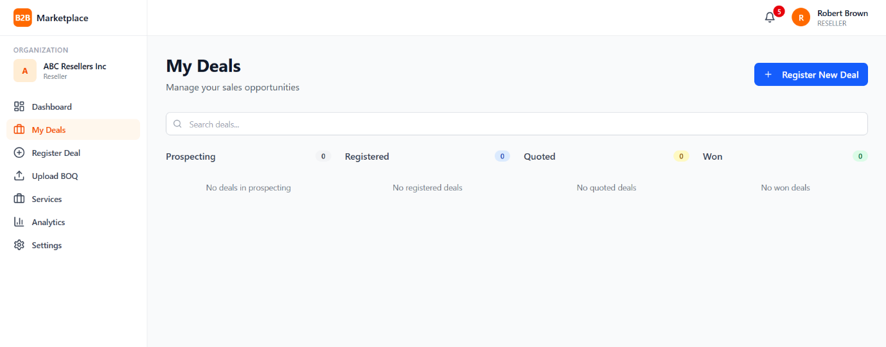
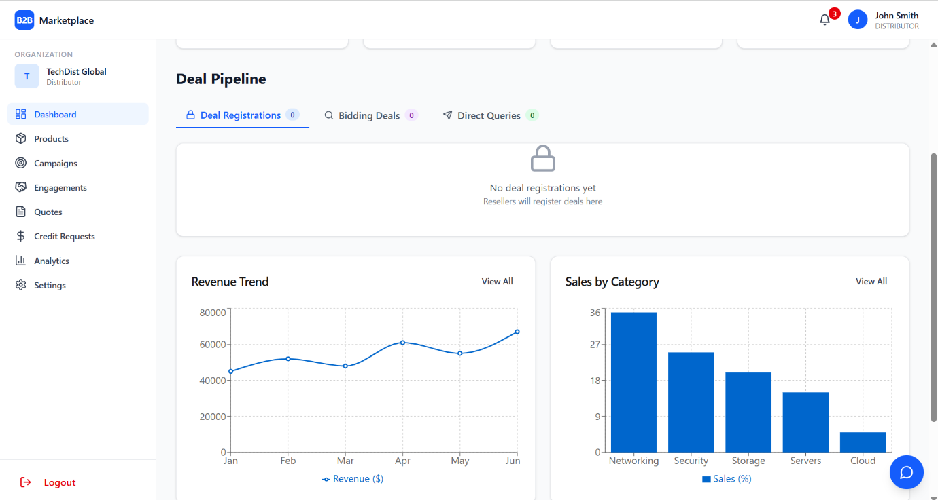
- Go to dashboard>> Register new Deal>> select deal type as open bidding>>customer info>>enter deal details>>click next to continue no email verification required>>error: please verify your email address before proceeding
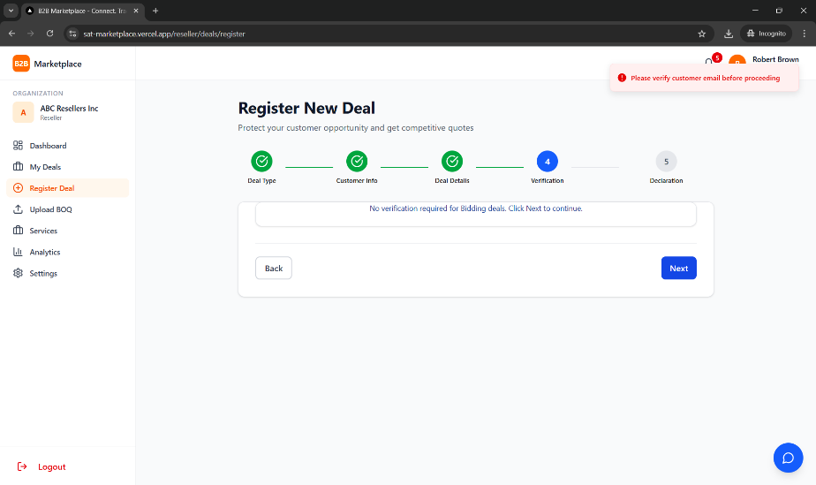
- Same above error shows for direct query type deal also. Refer steps of bug no.3
- Go to upload BOQ menu>>Upload an XLXS file>>scroll down check select drop down list to select , no deal available to select>>select visibility setting from drop down>> click submit BOQ CTA>> throws an error please upload a file to select a deal where already a file is already uploaded.
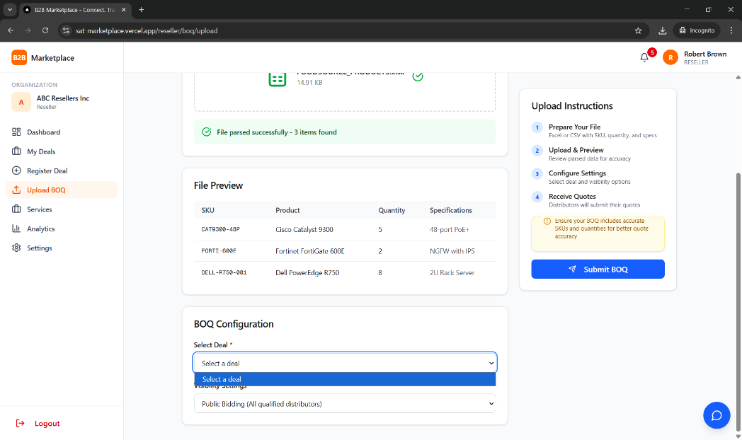
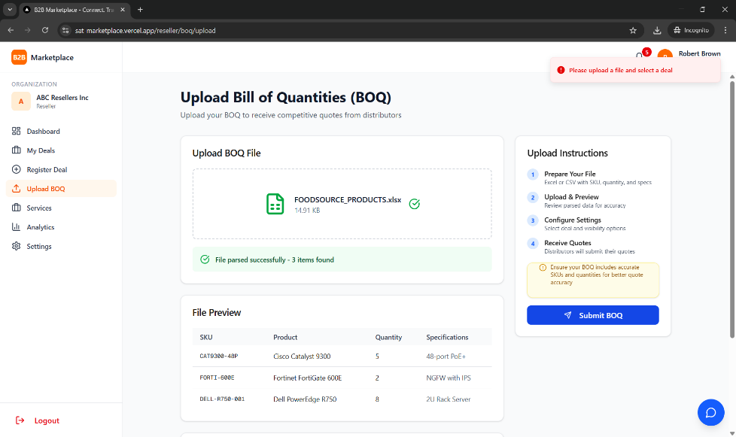
- Go to services menu click any CTA it gives toast message w.r.t CTA coming soon.
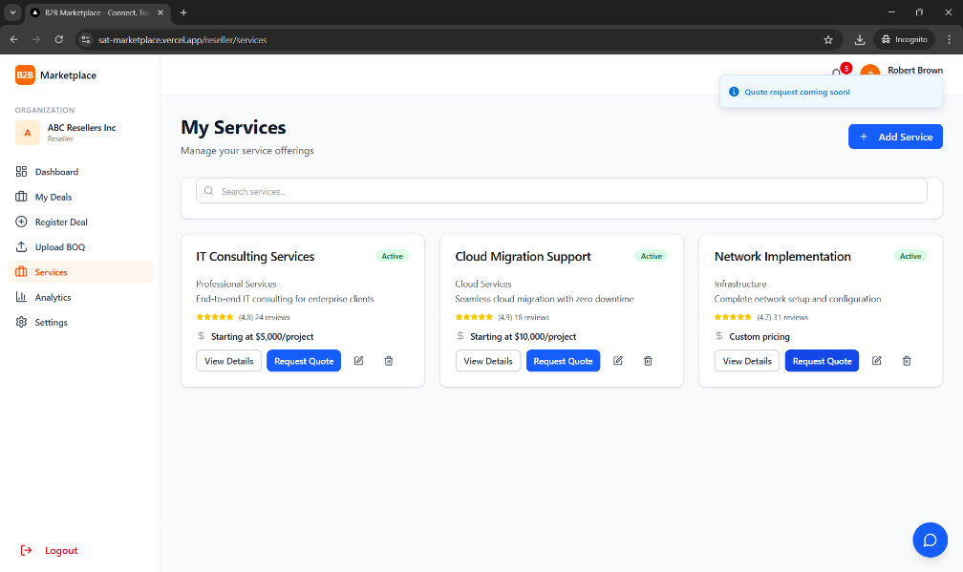
- Settings>> Invite team members section >> enter email id >> select role from drop down list>>click send invitation>> no emails/comms sent to actual/valid email id.
0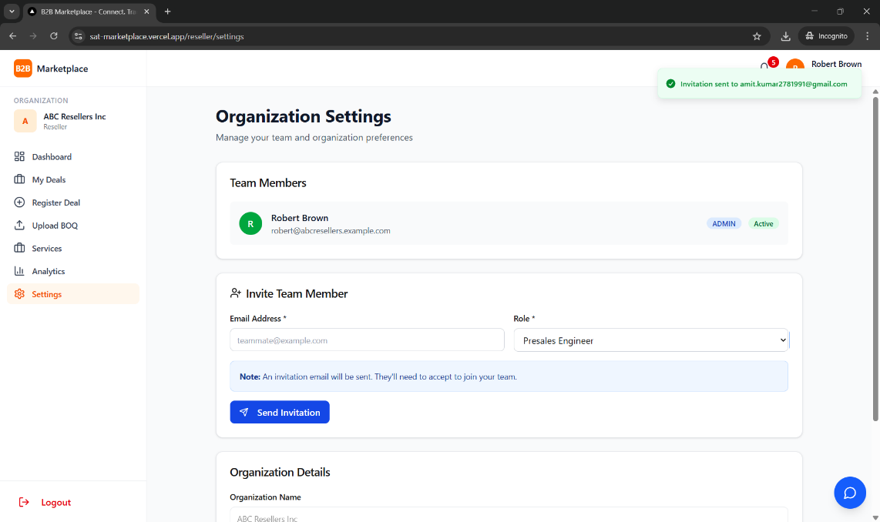
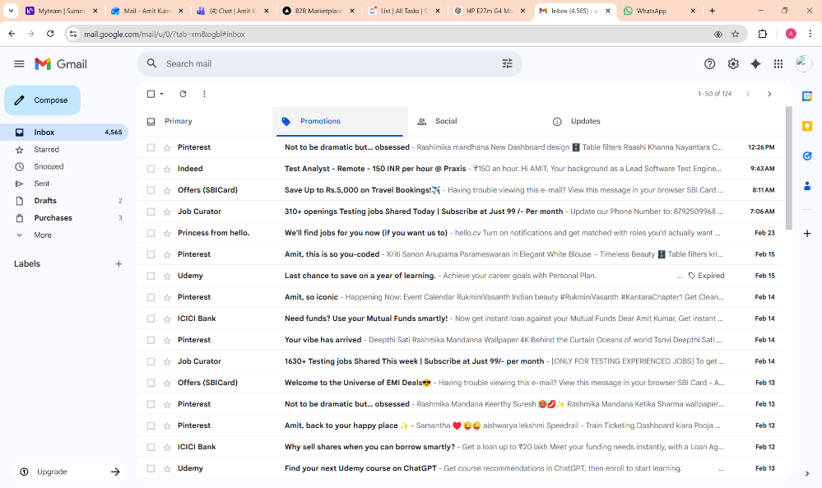
- Settings>> Organisational details >> non editable >> no clarity of its use.
User is unable to edit these details.
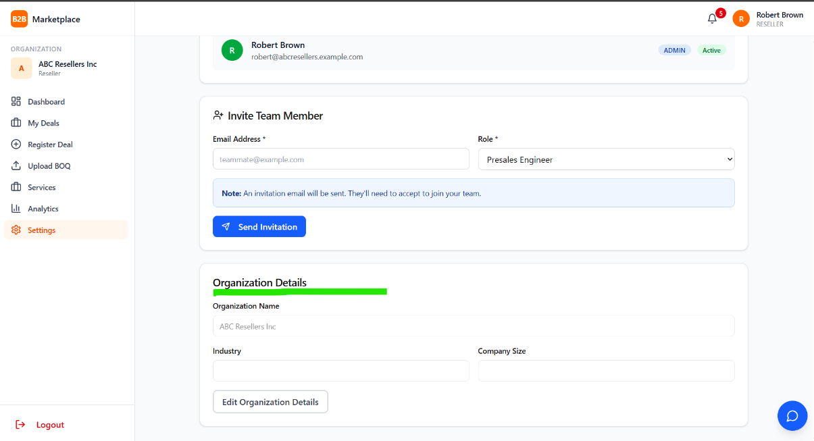

DISTRIBUTOR:
- Products>> click add your first product >>enter product details>>click save as draft /publish.>> error:could not find the ‘category’ column of the ‘products’ in schema cache.

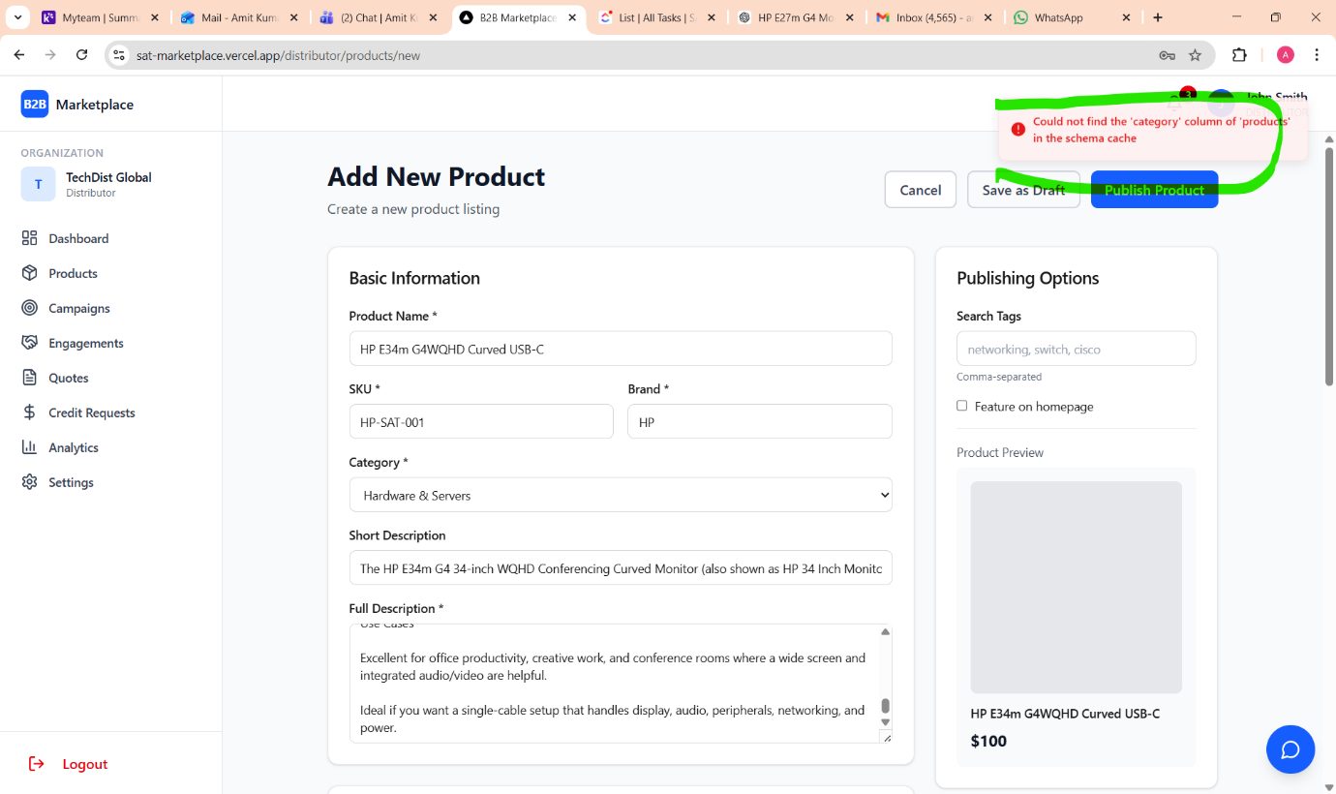
- Products>> check by clicking import CSV CTA >> check Export CTA >> both of them are non-functional.
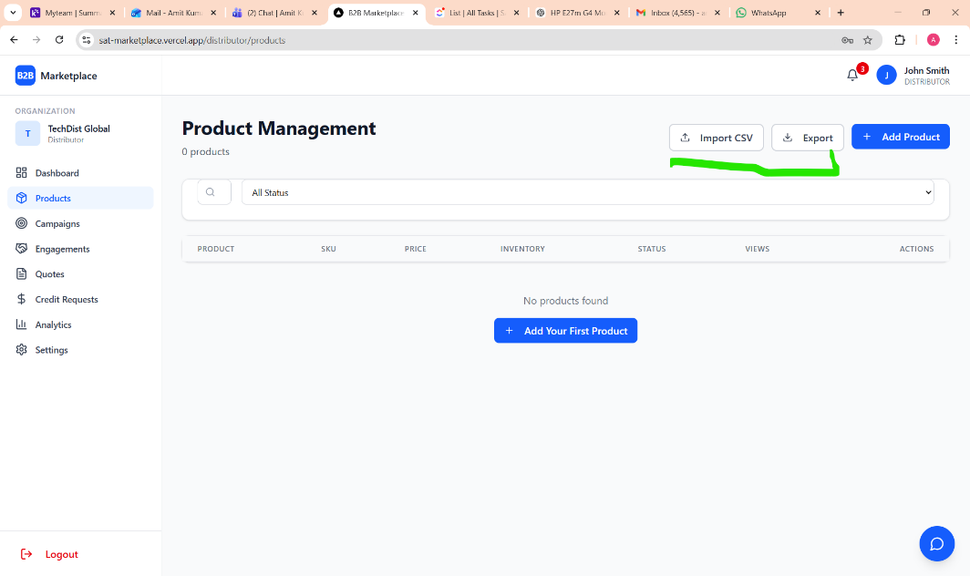
- Create campaign >> fill data >> launch campaign>> not reflecting at frontend.
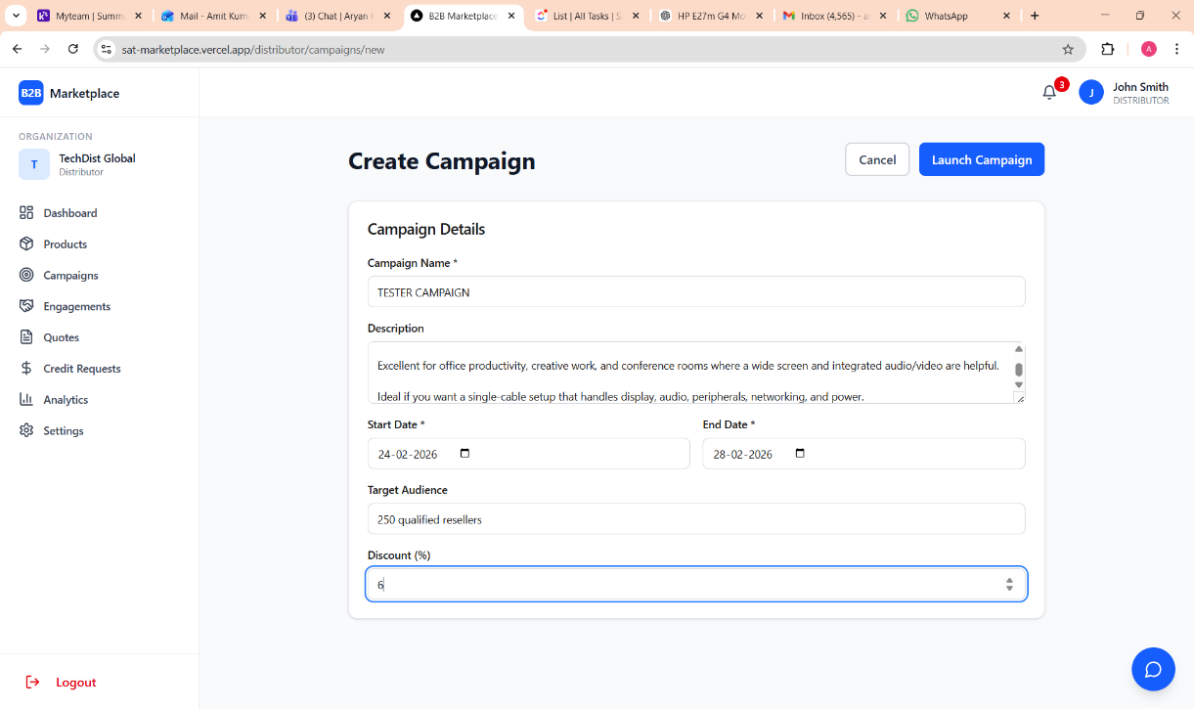
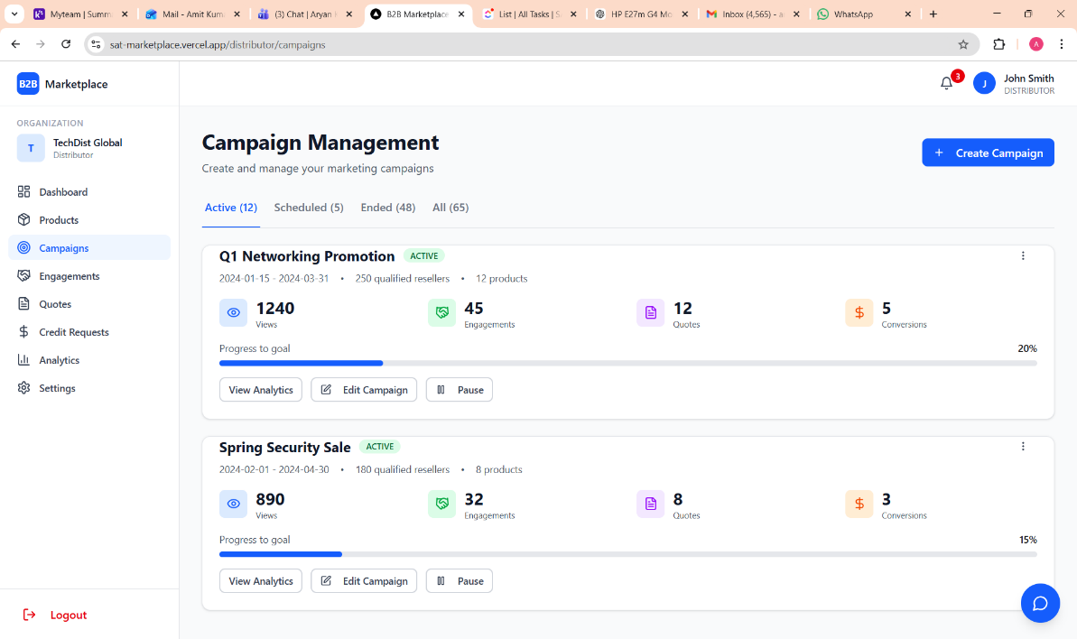
- Go to campaign menu>> click all CTA one by one of any existing campaign>> no CTA are functional. E.g—view analytics,edit campaign,pause.
- Go to Campaign menu>> check all existing tabs for campaigns >> all of shows same campaigns or static data.
- Go to Engagement menu>>check for pendings for approval.no data vsible.
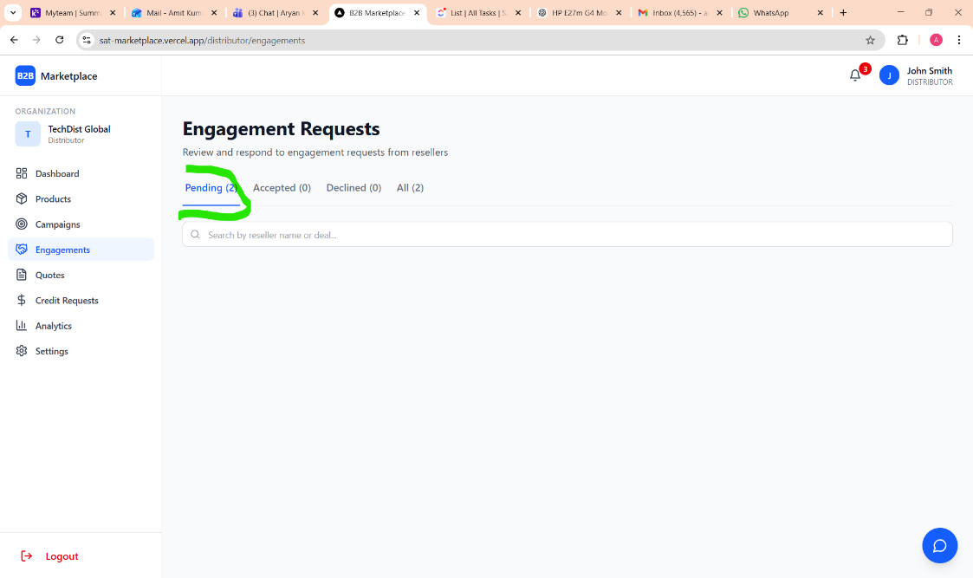
- Quotes section>> click view details of quotes>> no quotes found>> click go back then why its showing on frontend.

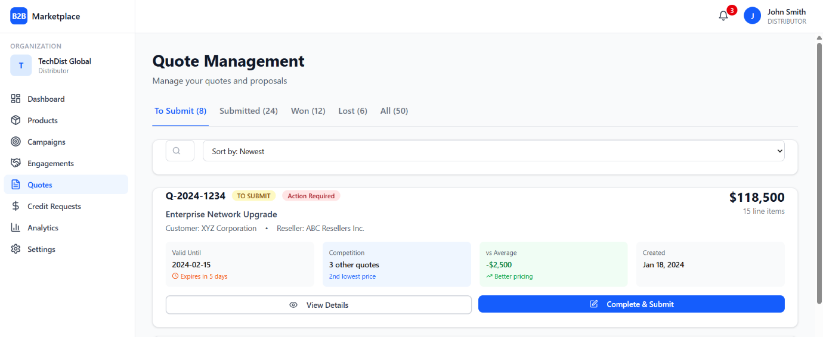
- Quote Section>> scroll down>>click generate invoice CTA>>it’s non-functional.
- Quote Section>> scroll down>>click update quotes CTA>> it’s non-functional.
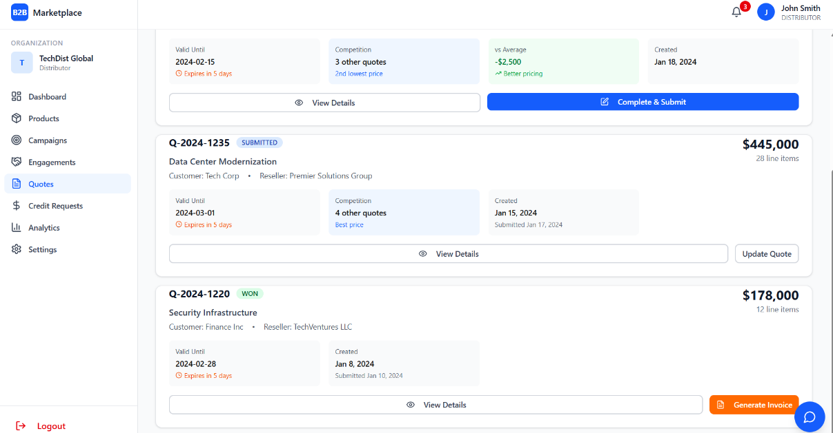

- Credit request >> all CTA’s non-functional. Such as review documents, approve, decline,request more info and download CTA’s
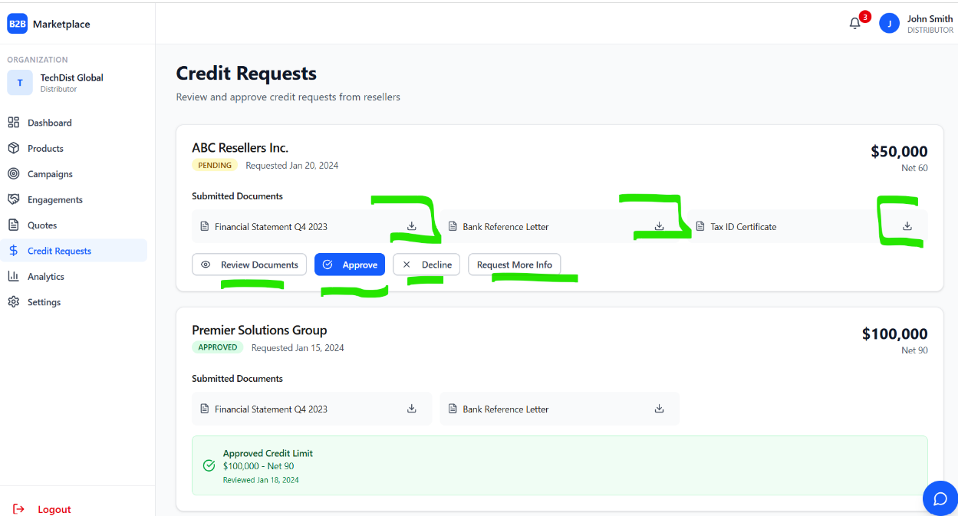
- Analytics section>> Select days to filter>> no impact on data.
- Analytics sections>> cards such as active customers, orders should be functional and redirect to respective page.
- Settings>> Invite team members section >> enter email id >> select role from drop down list>>click send invitation>> no emails/comms sent to actual/valid email id.
- Settings>> Organisational details >> non editable >> no clarity of its use.

ADMIN PANEL:
- Login as admin>> go to organisation page>> check CTA’s available>> Review, Approve, Reject CTA are not provided only view details is given. Without these CTA how admin will approve or reject any organisation.
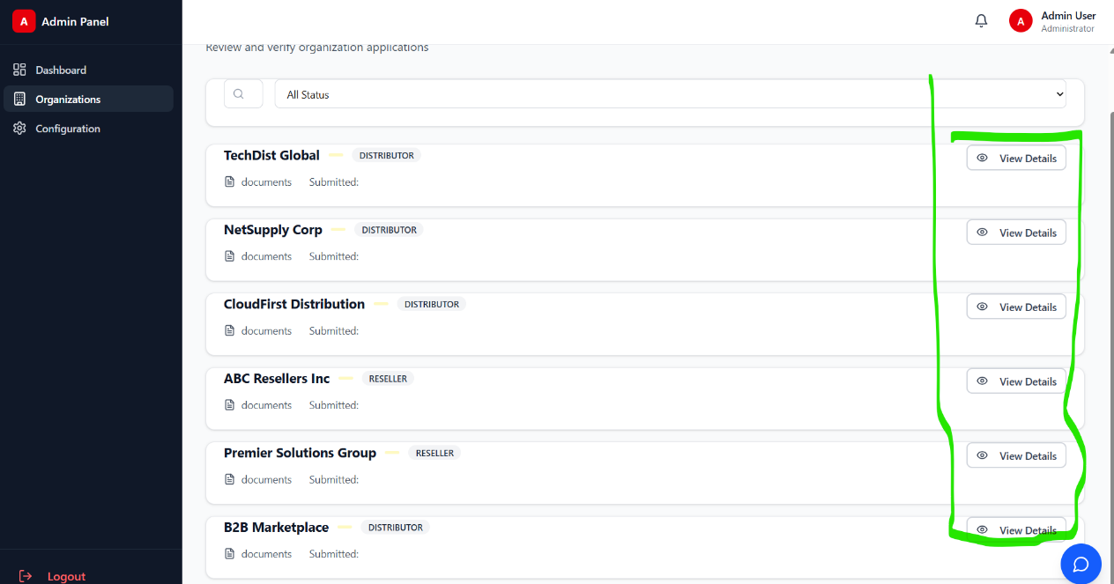
- Go to organisation page>>no pending or verified organisation shown by using filter from drop down list.
- Configuration>> click add category>> enter category name>>no options to add no.of products>>click save all changes>> refresh page>> check for added category. Not reflecting on UI.
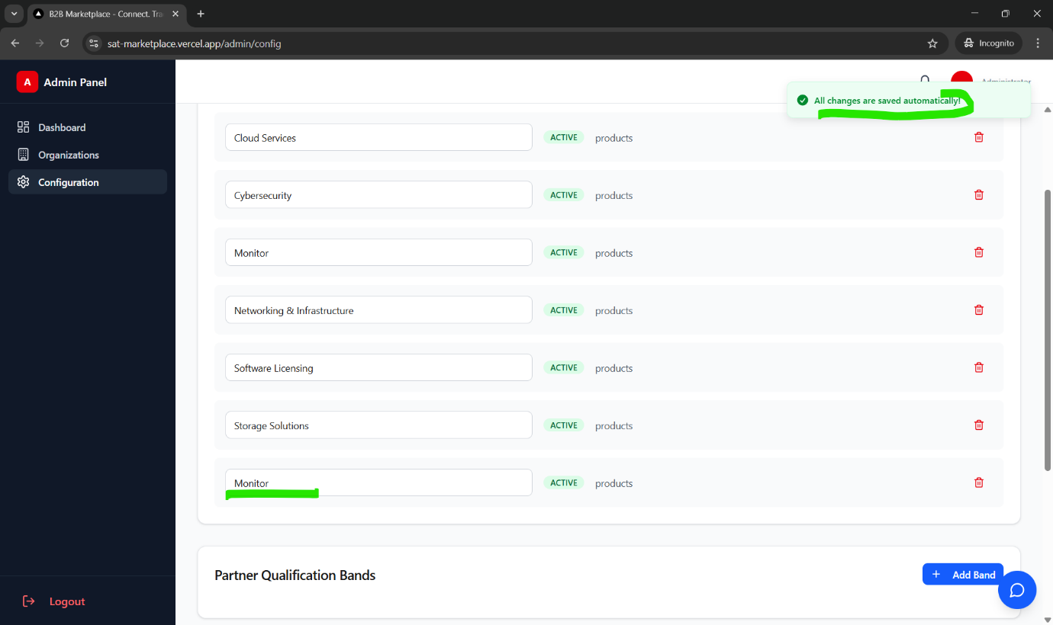
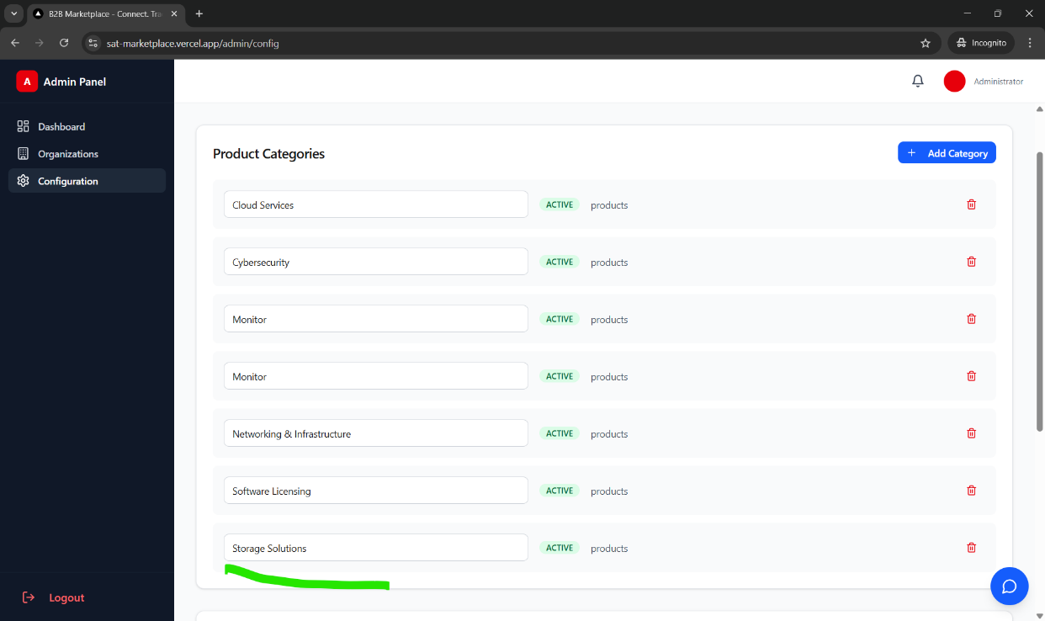
- Configurations>> navigate to partner qualifications band secton>> add band CTA non functional.
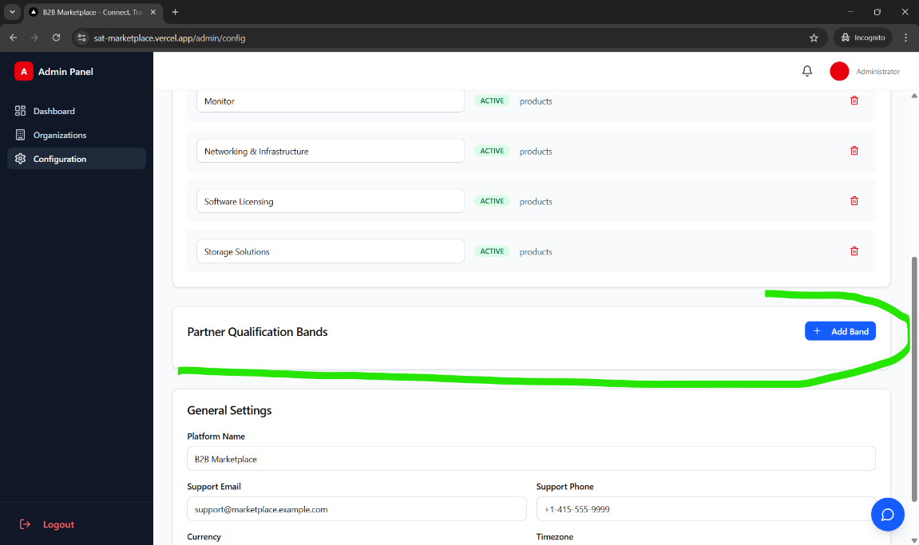
- Configurations>> navigate to general settings section>> make changes>> click save changes>> refresh page >> changes not updated and reflecting on UI.
